DAY-2

5.Write a C program for generalization of the Caesar cipher, known as the affine Caesar cipher, has the following form: For each plaintext letter p, substitute the ciphertext letter C: C = E([a, b], p) = (ap + b) mod 26 A basic requirement of any encryption algorithm is that it be one-to-one. That is, if p q, then E(k, p) E(k, q). Otherwise, decryption is impossible, because more than one plaintext character maps into the same ciphertext character. The affine Caesar cipher is not one-to-one for all values of a. For example, for a = 2 and b = 3, then E([a, b], 0) = E([a, b], 13) = 3.

a. Are there any limitations on the value of b?

b. Determine which values of a are not allowed.

Program:

#include <stdio.h>

#include <string.h>

void affineCipher(char plain[], int key[])

{

int i, x;

char cipher[strlen(plain)];

for (i = 0; i < strlen(plain); i++) {

x = plain[i] - 'a';

x = (key[0] * x + key[1]) % 26;

cipher[i] = x + 'a';

}

printf("Ciphertext: %s", cipher);

}

int main() {

int key[] = { 17, 20 };

char plain[] = "twenty fifteen";

affineCipher(plain, key);

return 0;

}

Output:

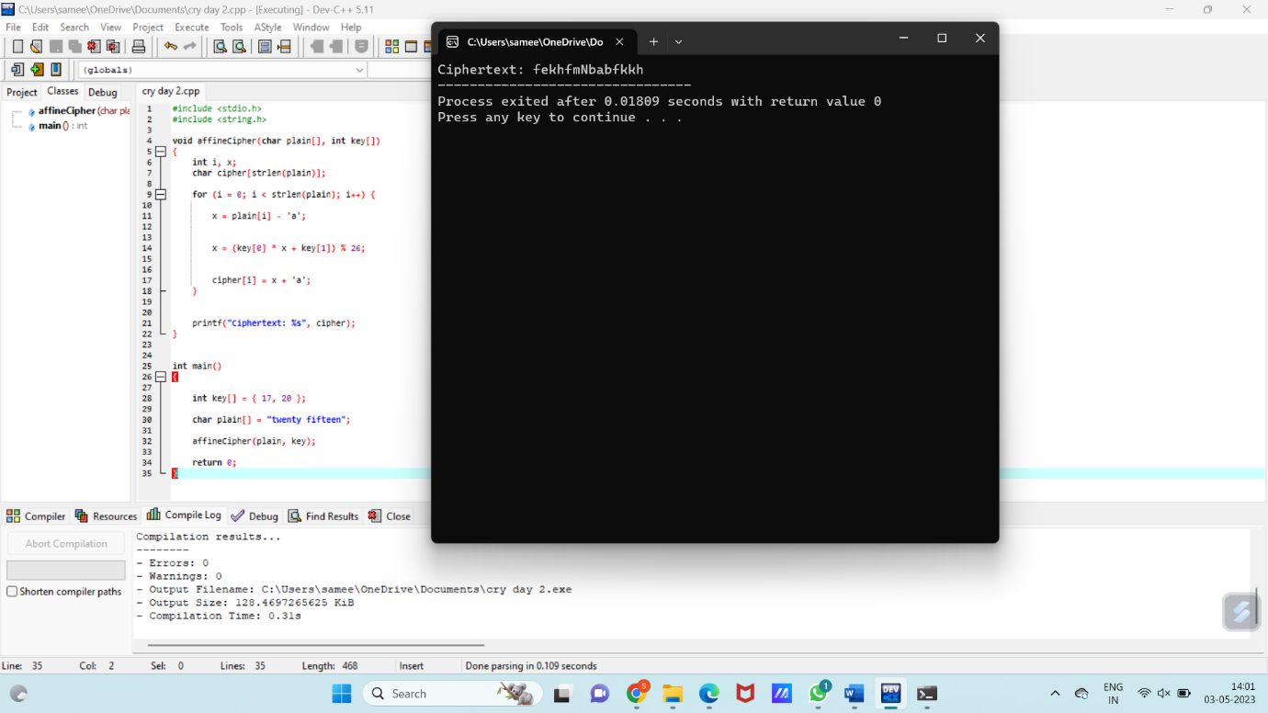

6. Write a High level code for ciphertext has been generated with an affine cipher. The most frequent letter of the ciphertext is “B,” and the second most frequent letter of the ciphertext is “U.” Break this code.

Program:

import java.util.HashMap;

import java.util.Map;

import java.util.Scanner;

public class AffineCipherBreaker {

private static final String ALPHABET = "ABCDEFGHIJKLMNOPQRSTUVWXYZ";

public static void main(String[] args) {

Scanner read = new Scanner(System.in);

String ciphertext = read.nextLine();

Map<Character, Integer> frequencyMap = new HashMap<>();

for (char c: ciphertext.toCharArray()) {

frequencyMap.put(c, frequencyMap.getOrDefault(c, 0) + 1);

}

char mostFrequent = 'A';

char secondMostFrequent = 'A';

int highestFrequency = 0;

int secondHighestFrequency = 0;

for (char c : frequencyMap.keySet()) {

int frequency = frequencyMap.get(c);

if (frequency > highestFrequency) {

secondMostFrequent = mostFrequent;

secondHighestFrequency = highestFrequency;

mostFrequent = c;

highestFrequency = frequency;

} else if (frequency > secondHighestFrequency) {

secondMostFrequent = c;

secondHighestFrequency = frequency;

}

}

System.out.println("Most frequent letter: " + mostFrequent);

System.out.println("Second most frequent letter: " + secondMostFrequent);

}

}

Output:

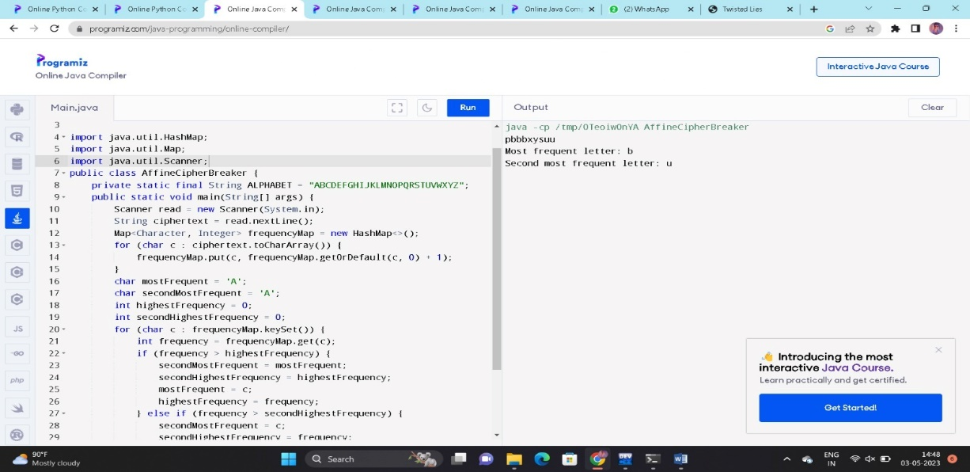

7. Write a C program for monoalphabetic cipher is that both sender and receiver must commit the permuted cipher sequence to memory. A common technique for avoiding this is to use a keyword from which the cipher sequence can be generated.

For example, using the keyword CIPHER, write out the keyword followed by unused letters in normal order and match this against the plaintext letters:

plain: a b c d e f g h i j k l m n o p q r s t u v w x y z

cipher: C I P H E R A B D F G J K L M N O Q S T U V W X Y Z

program:

#include<stdio.h>

char monocipher_encr(char);

char alpha[27][3] = { { 'a', 'c' }, { 'b', 'i' }, { 'c', 'p' }, { 'd', 'h' }, {

'e', 'e' }, { 'f', 'r' }, { 'g', 'a' }, { 'h', 'b' }, { 'i', 'd' }, {

'j', 'f' }, { 'k', 'g' }, { 'l', 'j' }, { 'm', 'k' }, { 'n', 'l' }, {

'o', 'm' }, { 'p', 'n' }, { 'q', 'o' }, { 'r', 'q' }, { 's', 's' }, {

't', 't' }, { 'u', 'u' }, { 'v', 'v' }, { 'w', 'w' }, { 'x', 'x' }, {

'y', 'y' }, { 'z', 'z' } };

char str [20];

int main() {

char str[20], str2[20];

int i;

printf("\n enter a plaintext..");

gets(str);

for (i = 0; str[i]; i++) {

str2[i] = monocipher_encr(str[i]);

}

str2[i] = '\0';

printf("\n Before Decryption..%s", str);

printf("\n After Decryption...%s\n", str2);

}

char monocipher_encr(char a) {

int i;

for (i = 0; i < 27; i++) {

if (a == alpha[i][0])

break;

}

return alpha[i][1];

}

Out put:

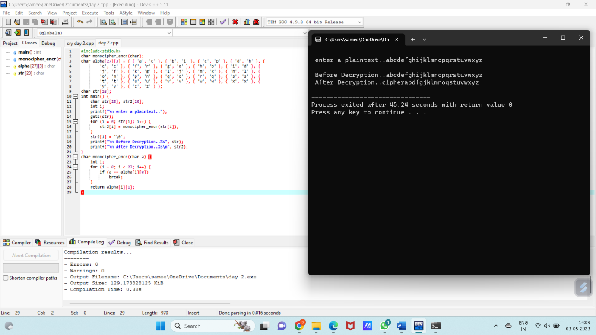

8. Write a C program for Playfair matrix:

M F H I/J K

U N O P Q

Z V W X Y

E L A R G

D S T B C

Encrypt this message: Must see you over

Program:

def toLowerCase(text):

return text.lower()

def removeSpaces(text):

newText = ""

for i in text:

if i == " ":

continue

else:

newText = newText + i

return newText

def Diagraph(text):

Diagraph = []

group = 0

for i in range(2, len(text), 2):

Diagraph.append(text[group:i])

group = i

Diagraph.append(text[group:])

return Diagraph

def FillerLetter(text):

k = len(text)

if k % 2 == 0:

for i in range(0, k, 2):

if text[i] == text[i+1]:

new_word = text[0:i+1] + str('x') + text[i+1:]

new_word = FillerLetter(new_word)

break

else:

new_word = text

else:

for i in range(0, k-1, 2):

if text[i] == text[i+1]:

new_word = text[0:i+1] + str('x') + text[i+1:]

new_word = FillerLetter(new_word)

break

else:

new_word = text

return new_word

list1 = ['a', 'b', 'c', 'd', 'e', 'f', 'g', 'h', 'i', 'k', 'l', 'm',

'n', 'o', 'p', 'q', 'r', 's', 't', 'u', 'v', 'w', 'x', 'y', 'z']

def generateKeyTable(word, list1):

key_letters = []

for i in word:

if i not in key_letters:

key_letters.append(i)

compElements = []

for i in key_letters:

if i not in compElements:

compElements.append(i)

for i in list1:

if i not in compElements:

compElements.append(i)

matrix = []

while compElements != []:

matrix.append(compElements[:5])

compElements = compElements[5:]

return matrix

def search(mat, element):

for i in range(5):

for j in range(5):

if(mat[i][j] == element):

return i, j

def encrypt_RowRule(matr, e1r, e1c, e2r, e2c):

char1 = ''

if e1c == 4:

char1 = matr[e1r][0]

else:

char1 = matr[e1r][e1c+1]

char2 = ''

if e2c == 4:

char2 = matr[e2r][0]

else:

char2 = matr[e2r][e2c+1]

return char1, char2

def encrypt_ColumnRule(matr, e1r, e1c, e2r, e2c):

char1 = ''

if e1r == 4:

char1 = matr[0][e1c]

else:

char1 = matr[e1r+1][e1c]

char2 = ''

if e2r == 4:

char2 = matr[0][e2c]

else:

char2 = matr[e2r+1][e2c]

return char1, char2

def encrypt_RectangleRule(matr, e1r, e1c, e2r, e2c):

char1 = ''

char1 = matr[e1r][e2c]

char2 = ''

char2 = matr[e2r][e1c]

return char1, char2

def encryptByPlayfairCipher(Matrix, plainList):

CipherText = []

for i in range(0, len(plainList)):

c1 = 0

c2 = 0

ele1_x, ele1_y = search(Matrix, plainList[i][0])

ele2_x, ele2_y = search(Matrix, plainList[i][1])

if ele1_x == ele2_x:

c1, c2 = encrypt_RowRule(Matrix, ele1_x, ele1_y, ele2_x, ele2_y)

elif ele1_y == ele2_y:

c1, c2 = encrypt_ColumnRule(Matrix, ele1_x, ele1_y, ele2_x, ele2_y)

else:

c1, c2 = encrypt_RectangleRule(

Matrix, ele1_x, ele1_y, ele2_x, ele2_y)

cipher = c1 + c2

CipherText.append(cipher)

return CipherText

text_Plain = 'MUST SEE YOU OVER'

text_Plain = removeSpaces(toLowerCase(text_Plain))

PlainTextList = Diagraph(FillerLetter(text_Plain))

if len(PlainTextList[-1]) != 2:

PlainTextList[-1] = PlainTextList[-1]+'z'

key = "MFHIKUNOPQZVWXYEL"

print("Key text:", key)

key = toLowerCase(key)

Matrix = generateKeyTable(key, list1)

print("Plain Text:", text_Plain)

CipherList = encryptByPlayfairCipher(Matrix, PlainTextList)

CipherText = ""

for i in CipherList:

CipherText += i

print("CipherText:", CipherText)

output:

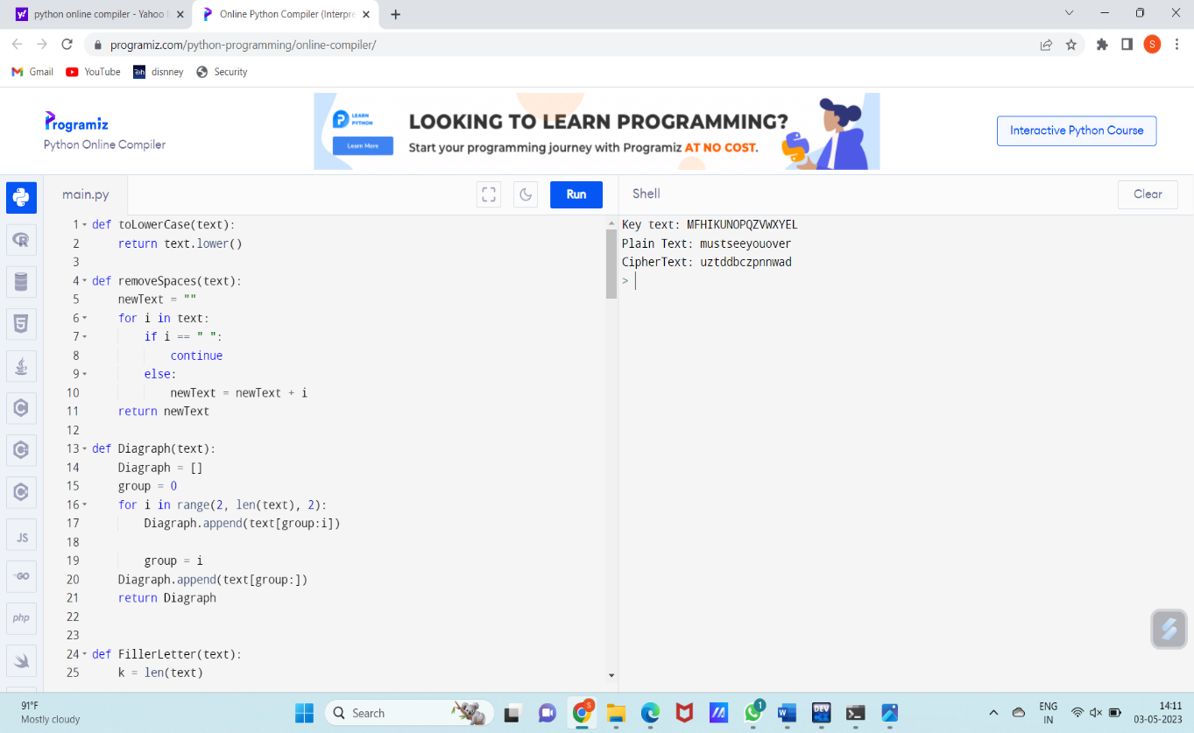

9. Write a high-level code for possible keys does the Playfair cipher have? Ignore the fact that some keys might produce identical encryption results. Express your answer as an approximate power of 2.

Program:

import itertools

def find_keyword():

alphabet = 'ABCDEFGHIKLMNOPQRSTUVWXYZ'

combinations = itertools.combinations(alphabet, 25)

for keyword in combinations:

matrix = [[0]*5 for _ in range(5)]

for i, letter in enumerate(keyword):

row = i // 5

col = i % 5

matrix[row][col] = letter

valid = True

for row in range(5):

for col in range(5):

if matrix[row][col] == 0:

valid = False

break

if matrix[row][col] == 'I' or matrix[row][col] == 'J':

matrix[row][col] = 'IJ'

if matrix[row][col] in matrix[row][col+1:] + [matrix[i][col] for i in range(row+1, 5)]:

valid = False

break

if not valid:

break

if valid:

return keyword

return None

keyword = find_keyword()

if keyword is not None:

print(f"The keyword is {keyword}.")

print(f"Its approximate power of 2 is {2**(len(keyword)*5):,.0f}.")

else:

print("No valid keyword was found.")

Output:

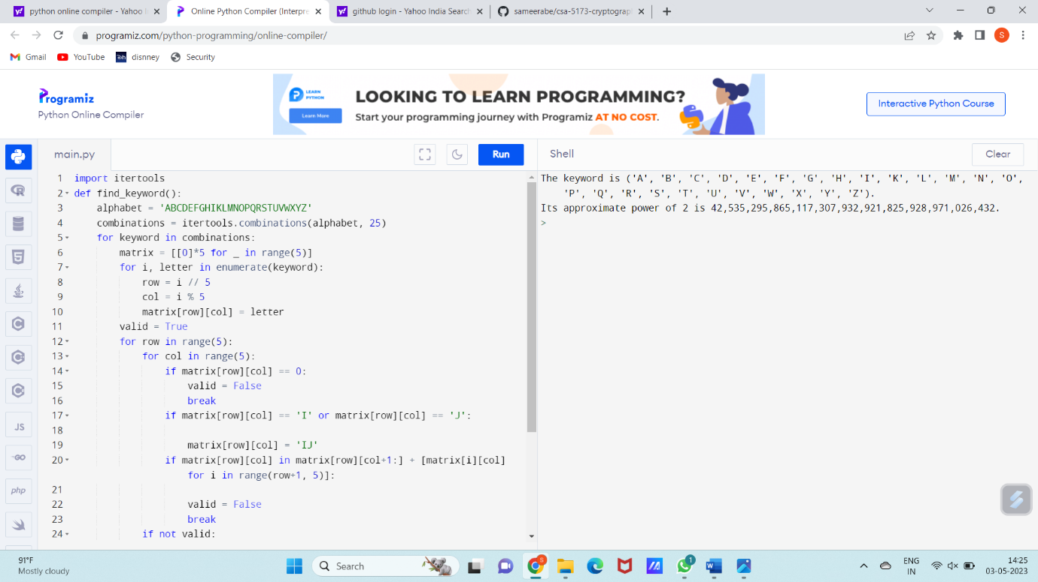

10. Write a high-level code to Encrypt the message “meet me at the usual place at ten rather than eight o’clock” using the Hill cipher with the key.

9 4

5 7

a. Show your calculations and the result.

b. Show the calculations for the corresponding decryption of the ciphertext to recover the original plaintext.

Program:

key = [[9, 4], [5, 7]]

plaintext = "meet me at the usual place at ten rather than eight oclock"

plaintext = plaintext.upper().replace(" ", "")

if len(plaintext) % 2 != 0:

plaintext += "X"

plaintext_vectors = []

for i in range(0, len(plaintext), 2):

pair = plaintext[i:i+2]

vector = [ord(pair[0])-65, ord(pair[1])-65]

plaintext_vectors.append(vector)

ciphertext_vectors = []

for vector in plaintext_vectors:

ciphertext_vector = [(key[0][0]*vector[0] + key[0][1]*vector[1]) % 26, (key[1][0]*vector[0] + key[1][1]*vector[1]) % 26]

ciphertext_vectors.append(ciphertext_vector)

ciphertext = ""

for vector in ciphertext_vectors:

pair = chr(vector[0]+65) + chr(vector[1]+65)

ciphertext += pair

print(ciphertext)

output:

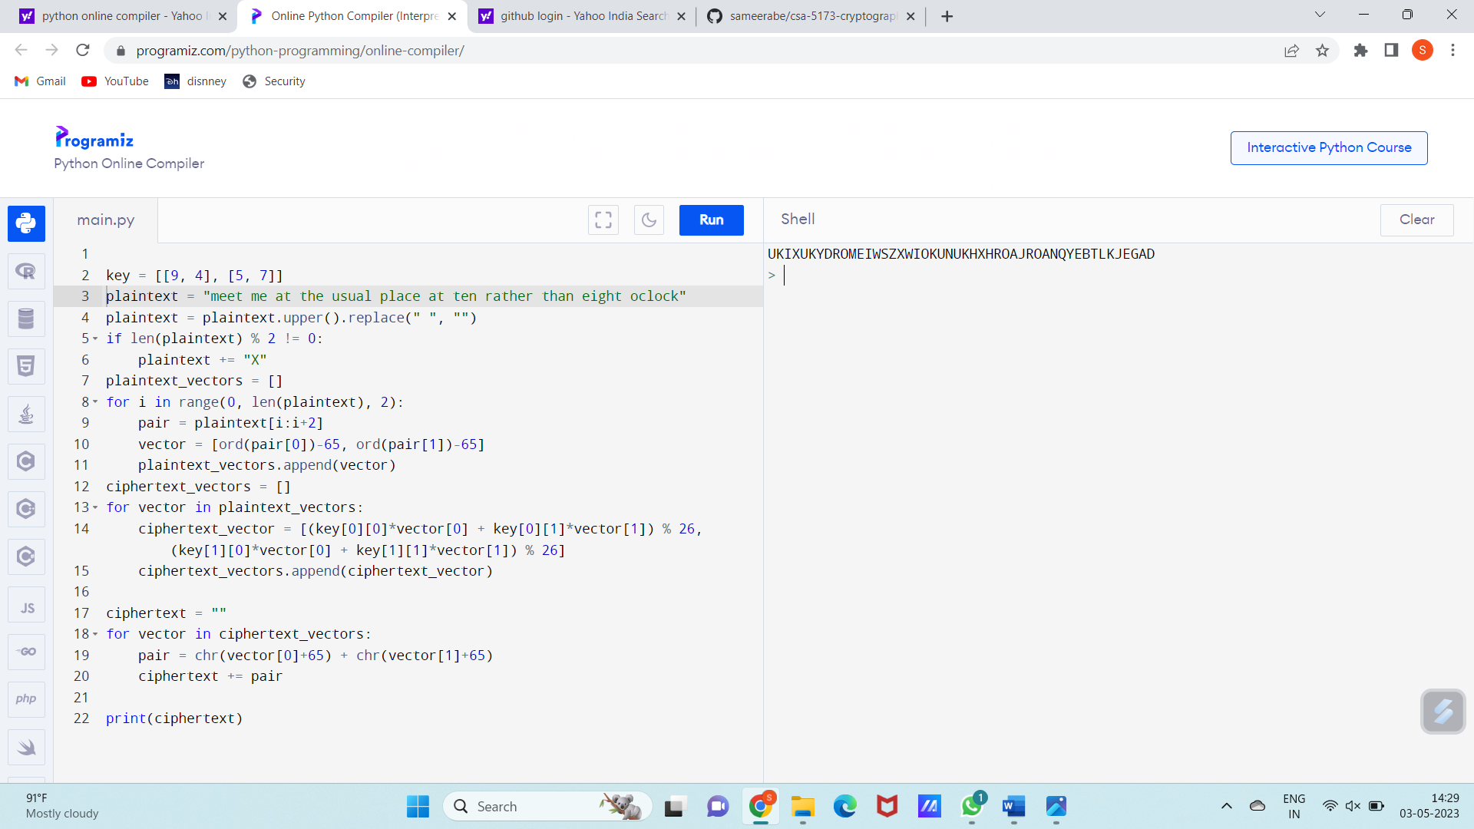

11. Write a high-level language program for one-time pad version of the Vigenère cipher. In this scheme, the key is a stream of random numbers between 1 and 26. For example, if the key is 3 19 5 . . ., then the first letter of the plaintext is encrypted with a shift of 3 letters, the second with a shift of 19 letters, the third with a shift of 5 letters, and so on. Encrypt the plaintext send more money with the key stream

9 0 1 7 23 15 21 14 11 11 2 8 9

Program:

def vigenere_otp_encrypt(plaintext, key_stream):

ciphertext = ""

key_index = 0

for char in plaintext:

shift = key_stream[key_index]

if char.isalpha():

if char.isupper():

ciphertext += chr((ord(char) - 65 + shift) % 26 + 65)

else:

ciphertext += chr((ord(char) - 97 + shift) % 26 + 97)

key_index = (key_index + 1) % len(key_stream)

else:

ciphertext += char

return ciphertext

# Example usage

plaintext = "sendmoremoney"

key_stream = [9, 0, 1, 7, 23, 15, 21, 14, 11, 11, 2, 8, 9]

ciphertext = vigenere_otp_encrypt(plaintext, key_stream)

print(ciphertext)

Output:

